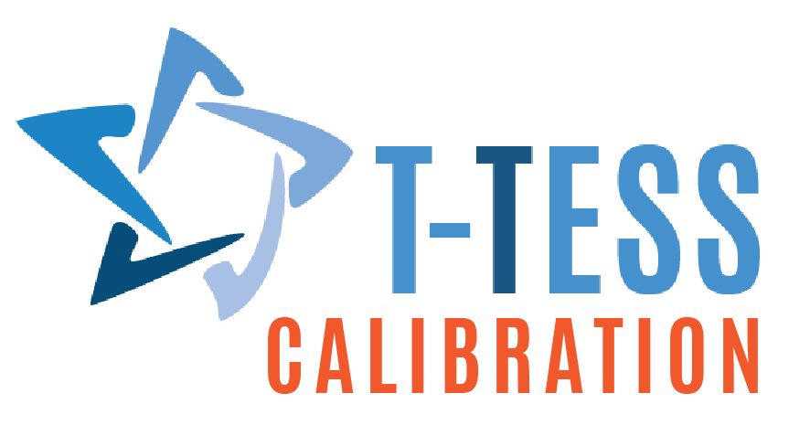

Observation Calibration Protocols

Purpose

Calibration protocols are procedures used to increase calibration between appraisers and between campuses throughout the year. When used strategically, they can help increase scoring accuracy by providing appraisers opportunities to practice collecting defensible evidence for ratings. They also help appraisers develop a deeper understanding of what effective instruction looks like across a variety of contexts and ensure that each appraiser in the district is aligned in how they are evaluating teachers.Appraiser Development vs. Calibration
At times, these protocols may be used to coach and develop appraisers through practice and feedback. At other times, the protocols may be used to evaluate whether appraisers are appropriately calibrated to the district’s standards.

Best Practices to Implement Protocols
- Create a schedule of calibration activities that span the year.
- Designate times for appraisers at different campuses to calibrate together.
- Ensure that district leaders are certified and calibrating alongside campus appraisers.
- Define calibration by establishing a common working definition of calibrations and communicate what it will look and sound like for team members. This is important to moving the work. Decide what it means for two appraisers to be calibrated to each other on a given calibration activity. Do they need to match on every rating? Do they need to be within one on each dimension? Do they need to match on a certain percentage of ratings?)
- Establish internal calibration protocols and procedures to assist team members in participating and documenting the process.
- Create a schedule of calibration activities and involve team members in identifying the need and creating schedules of calibration activities. Hold true to these activities and times.
- Calibrations should occur within and among campuses. This is important to ensure that there is consistency within the campus and across campuses.
- Observation data analysis should be used to determine skew and dimensions of focus. Analysis of data at the overall level, by domain and by dimension are all important when looking at calibration data and potential skews.
- District leadership is ideally included in calibration activities. Including others outside the campus provides them opportunities to delve into the work, and support campuses at the macro level.

High-Quality Evidence
During calibration debriefings, discuss evidence before sharing ratings so that everyone understands not only what the rating should be but also why. Quality evidence is objective and states exactly what teachers said or did.
- Low-quality evidence: The teacher checked for understanding after modeling one problem.
- High quality evidence: After modeling one problem, the teacher asked each student to attempt a second problem on individual white boards (15 x 24). The teacher circulated as students worked and wrote down common errors she was seeing in students’ work. Then, all students raised their boards so she could see how many students were able to complete the problem successfully on their own. 15 out of 22 students were successful.

